**Emergency Preparedness**

**Selected Resources**

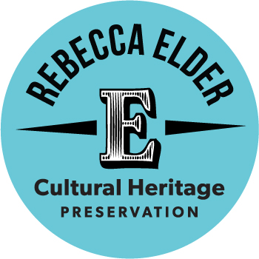

**Organizations**

National Heritage Responders

<https://www.culturalheritage.org/resources/emergencies/national-heritage-responders>

FEMA

<http://www.fema.gov>

Northeast Document Conservation Center

[www.nedcc.org](http://www.nedcc.org)

**Publications**

Field Guide to Emergency Response

<https://store.culturalheritage.org/site/index.php?app=ecom&ns=prodshow&ref=FAIC-2>

Emergency Response and Salvage Wheel

<http://store.conservation-us.org/site/index.php?app=ecom&ns=prodshow&ref=FAIC-1>

**Websites**

dPlan.org

<https://www.dplan.org>

CoSA Pocket Response Plan

<https://www.statearchivists.org/research-resources/emergency-preparedness/pocket-responce-templates>

California Preservation Program Emergency Resources

<https://calpreservation.org/information_resources/emergency-prep-and-response/>

FEMA Incident Command Training

<https://training.fema.gov/nims/>

WAAC’s Salvage at a Glance Chart

<http://hosted.lib.uiowa.edu/flood/salvage_chart.html>

National Park Service Conserve-o-Grams

<https://www.nps.gov/museum/publications/conserveogram/cons_toc.html>

Health and Safety in Emergency Response Wiki

<http://www.conservation-wiki.com/wiki/Health_%26_Safety:_Health_and_Safety_in_Emergency_Response>

National Heritage Responders Tip Sheets

<https://www.culturalheritage.org/resources/emergencies/national-heritage-responders/tip-sheets>

NEDCC Preservation Leaflets

<https://www.nedcc.org/free-resources/preservation-leaflets/overview>

Emergency! If You’re First

<https://www.culturalheritage.org/docs/default-source/resources/emergency-resources/guides/emergency-if-you're-first.pdf?sfvrsn=4>

Connecting to Collections Care

[www.connectingtocollections.org](http://www.connectingtocollections.org)

AIC YouTube Channel

<https://www.youtube.com/user/aiconservation/playlists>